Start Gcode

G90 ; Set to Absolute Positioning
M82 ; Set extruder to absolute mode
G21 ; Metric values
G28 X Y
G92 Z0 E0 ; Set all axis to 0
;home X
G1 Y2 ; Move Y axis off the bed
G28 X0 F2000 ; Home X axis
G1 X200 Z5 F4000 ; Move X to the center
;probe Y
M908 P5 S10 ; Setting the motor current of the Y1 motor off
M908 P1 S10 ; Setting the motor current of the Y2 motor off
G1 Y20 G3000 ; Move Y up
M400 ; Wait for current moves to finish
M908 P5 S25 ; Setting the motor current of the Y1 motor very low
M908 P1 S25 ; Setting the motor current of the Y2 motor off
G1 Y0 F500 ; Move Y down into the belt
M400 ; Wait for current moves to finish
M908 P5 S140 ; Setting the motor current of the Y1 motor to normal
M908 P1 S140 ; Setting the motor current of the Y2 motor to normal
G92 Y{blackbelt_z_offset}
;purge
G1 Y2 ; Move Y axis off the bed
G1 F15000 ; Set high feedrate
G1 X200 Y 1 G1 E10; Extruder 10mm material and move to the side
G1 Z10 E12 F500;add
G1 X0 E32
G1 Z20 E34
G1 X200 E54

G1 Z30 E56 F500
G1 X0 E76
G1 Z40 E78
G1 X200 E98

G1 X0 Z40.2 E120
G92 E0 Z0
G1 E-4 F3900 ; Retract 4mm at 65mm/s

End Gcode
G92 E0 ; Set Extruder to zero
G1 E-6 ; Retract 6mm
G92 Z0 ; Set Belt to zero
G1 Z15 ; Move Belt 15mm before starting up the next product
G92 Z0 ; Set Belt to zero again

;-----copy up to here / paste codes just above here-----

M104 S0 ; Extruder heater off
M140 S0 ; Heated bed heater off
M106 S0 ; Part cooling fan off
M106 P1 S0 ; Rear fan off
G92 Z0
G1 Z20 F1000
G28 X0 F2000
G1 Y10 F2000
M18 ; Disable all stepper motors

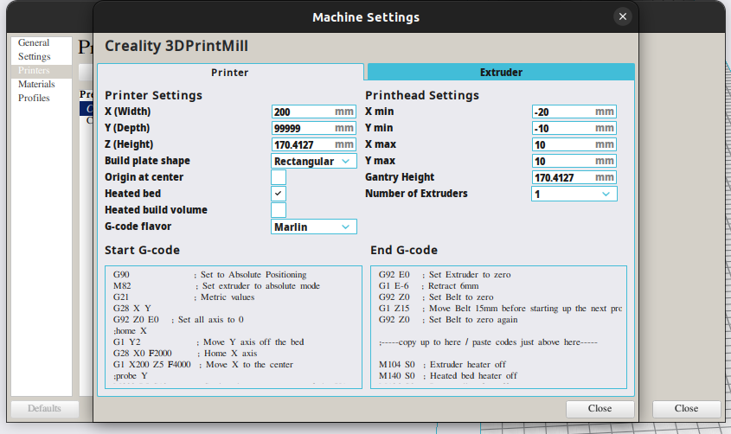

G90 ; Set to Absolute Positioning
M82 ; Set extruder to absolute mode
G21 ; Metric values
;M808 L ; This is your looping code, any number after the L is the number of repeats, leave blank for infinite loops
M104 T0 S{temperature_extruder1} ; For some reason ideamaker forces the nozzle to cooldown when the command isnt even in the endgcode, this turns it straight back on after the loop, 245 is the degrees in this case
G28; Home
G92 X0 Y0 Z0 E0 ; zero out all axes (include extruder)
M83 ; set extruder to relative coordinates
G0 Z80 E25 ; extrude short Z line
G92 E0 Z0 ; Set all axis to 0
G0 X215 E40 F800 ; Primeline placed after the loop code so every looped print will get a primeline for better adhesion
G92 E0 Z0
M82
M117 Please stick...

